New 2017 laws prohibit drivers from holding cell phones while driving.

STOP TEXTING stickers help to protect drivers and passengers!

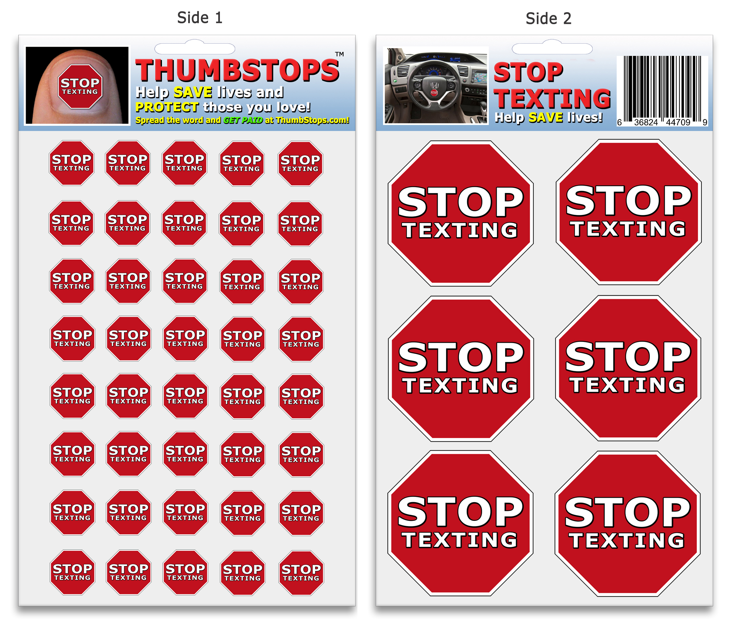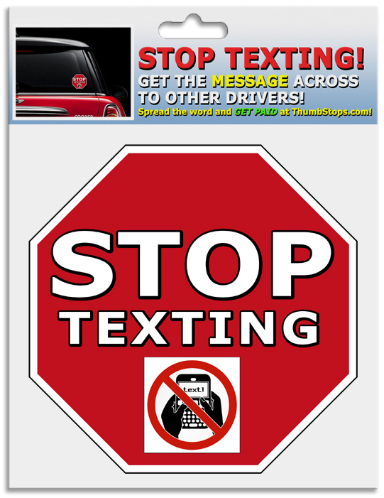

Your business is invited to join the ThumbStops-STOP TEXTING Business Partnership Program!

ThumbStops™ and STOP TEXTING stickers serve as simple and effective reminders to drivers, to STOP TEXTING while driving. This helps to PREVENT accidents, thus protecting drivers and passengers from serious injury and the loss of life. Packages include 40 small stickers for placing on the thumbnail, and 6 large stickers for placing on the steering wheel and other locations inside the car. Weatherproof exterior vehicle decals are also available for getting the message across to other motorists and come 3 per package.

To join the ThumbStops Partnership Program, simply go to the sign up link below and then choose the “Business” option. After logging in, you will have free access to our affiliate text and graphic banners. You will also receive a free affiliate hyperlink for referring customers, and a sub-affiliates sign up link to use when referring other businesses and organizations. This will enable your business to receive additional revenue when customers and members of referred businesses make purchases.

Affiliates can also download and print our full color ThumbStops Information Flyer (as a word doc), which allows you to append YOUR custom Referral ID to our site URL.
Example: www.ThumbStops.com?aff=YourBusinessNameorRefID.
Flyers can be printed and distributed to your customers or attached to an email newsletter. Your business earns a 20% commission for each customer who uses your affiliate link to make a purchase. You can also download our customizable business invitation like this one, and use your Referral ID at the bottom, and attach it to an email or newsletter.

Website text and graphic banners are available in the affiliate area for promoting to online customers.

www.ThumbStops.com/affiliatesignup

Referral ID:

